Shabbos Stories for
Parshas Vayechi 5783
Volume 14, Issue 17 – 14 Tevet 5783/January 7, 2023
Printed L’illuy nishmas Nechama bas R’ Noach, a”h

For a free subscription, please forward your request to keren18@juno.com
Past emails can be found on the website – ShabbosStories.com

Rejoicing in Our Struggles
By Rabbi Joey Haber

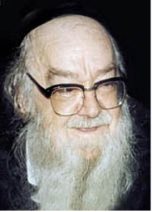

Rav Shalom Schwadron (1912-1997), who was known as “the Maggid of Yerushalayim,” once worked as a teacher in a yeshiva, and he noticed that a certain student did not attend the shiur for several nights in a row. He decided to go to the young man’s house and ask him why he had not been in the class, if perhaps he was ill or had some other problem.
The boy explained to him that the World Cup soccer competition was going on at that time. He was not attending the shiurim because he needed to watch the games… The boy assured the Rabbi that the following week, once the World Cup was over, he would come back to the shiur.

Rav Schwadron asked the boy what soccer was. The boy explained that there are two goals on both sides of the field, and each team has to try to kick the ball, without touching it with their hands, into the opposing team’s goal. “Ok,” the Rabbi replied. “That doesn’t sound too difficult. I could do that.”
“No, Rabbi, you don’t understand,” the boy explained. “The opposing team has a goalie that stands in the goal and blocks the ball so it won’t go in.”

“I see,” the Rabbi said. “I assume that if we go right now to a soccer field, there won’t be any goalie there. So why don’t we just go right now, and we can kick the ball into the goal all we want!!”
The boy laughed. “What would be the point?!” he said. “The whole fun is struggling against the opposing team to try to score goals.”
“Exactly!” the Rabbi exclaimed. “The point is to struggle. Attending shiur next week, after the World Cup is over, is simple. The real ‘fun’ is to struggle to attend shiur this week, when it’s not easy, when you have to make a sacrifice for it.”
Hashem created the world and our lives in such a way that we have to work hard to achieve. He intentionally did not make things easy – because if things were easy, then there would be no point in “scoring.” We achieve and grow through struggle and hard work.

Reprinted from the Parshat Mikess 5783 email of Rabbi David Bibi’s Shabbat Shalom from Cyberspace.
He Cheated the
Angel of Death
By Rabbi Aharon Loschak

Satan, the angel of death, and the evil inclination are all one (Bava Batra 16a).

Reb Shmaya was a venerable chassid of the Rebbe of Kotzk, Rabbi Menachem Mendel Morgenstern. Shmaya’s friends knew him as sincere, pious, and humble, more so than anyone else they knew.
And then, disaster struck. Shmaya fell deathly ill. His situation deteriorated, and before long, the end was approaching. He lay on his deathbed, frighteningly pale, holding onto the very last threads of life.
Those at his bedside noticed that he was murmuring to himself. Eager to hear the last words of this renowned and esteemed chassid, they quickly moved closer to bask in what was sure to be a deeply meaningful and awe-inspiring lesson.
Imagine their disappointment when they heard nothing of the sort. With the last vestiges of energy left in his frail body, Reb Shmaya turned to them and said, “You see, the evil inclination is always right there, ready to pounce and capitalize on my every move. Even now, as I lie here ready to meet my Maker, that wily and noxious creature is at my side, whispering:
“‘Reb Shmaya, now’s your chance! You’re about to die, and everyone is eager to hear what you’re going to say. Take the opportunity and go out like a star. Say Shema with all your might and make sure to really draw out the last word as is your habit. People will be so impressed, and they’ll remember you forever as a chassid of unparalleled piety and devotion. For centuries, people will say, “With such concentration, Reb Shmaya died with the last words of Shema on his lips!” Go for it; make your mark!’ ”
“I can’t give the evil inclination such a victory,” said Reb Shmaya, “so everyone leave me alone and let me die in peace.”
To everyone’s surprise, Reb Shmaya made a miraculous recovery. Word in Kotzk was that because he had denied the Angel of Death his big victory, he had given up and left him alone.¹

FOOTNOTES
1. Based on Sneh Bo’er BeKotzk (Orayin), p. 175; Bemaagalot Hachasidut (Orayin, Jerusalem 1978); and oral tradition.

Reprinted from the Parshat Mikeitz website of Chabad.Org Magazine.

Insult at the Car
Rental Line in Florida
By Rabbi Paysach J. Krohn

During one freezing winter in their hometown of Buffalo, NY, Rabbi [Moshe] Taub took his wife and children to Florida for a few days to get away from the hostile Buffalo weather. Their trip took much longer than expected. The plane was delayed on takeoff, it was a crowded plane, and eventually the children became impatient and cranky.
By the time the Taubs landed in Florida seven hours later and collected their luggage, they were drained and exhausted. As winter is the height of the vacation season in Florida, the line at the car rental office in the airport stretched from inside the building to the sidewalk.
The sun and humidity were stifling. By the time the family entered the building to continue waiting on the endless line, Rabi Taub was uncomfortably hot and his nerves were frazzled. There were at least 15 people ahead of him. As the Taubs stood in line for the car rental, a couple walked up with their luggage, apparently ignoring the long line, and cut in front of them. Rabbi Taub was shocked! What made it worse was that the man now standing in front of him was wearing a yarmulka.

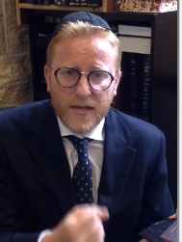
Rabbi Moshe Taub

Rabbi Taub lost his patience, furious that the man was making a chilul Hashem by disregarding the people standing behind them. Rabbi Taub impulsively said to the man, “Perhaps when you do such a thing it would be better if your yarmulka was not on your head!”
Rabbi Taub immediately regretted his harsh comment. When they finally got into their car, Mrs. Taub gently told her husband, “A Yid should never reprimand another Yid and tell him to take of his yarmulka. Maybe he was too overwhelmed by his trip and didn’t notice the line. Be dan l’kaf z’chus. Maybe he had a reason for what he did.”
Reason? Rabbi Taub could not imagine there was a reasonable reason. But he felt terrible about the comment he made. For years, he could not get this matter out of his mind. Every Erev Yom Kippur, he thought about the unknown Jew he had scolded and would probably never see again. He wanted to apologize and ask for forgiveness, but it was not going to happen.
Or so he thought… Four years later, once again the family planned a trip from snowy Buffalo to sunny Florida. This trip was even more harrowing than their first one, as not only was their plane delayed, but they had to make an emergency landing at Kennedy Airport. Their plane was again delayed by many hours at JFK, and they were put up in a hotel for the night. It took them a full 24 hours to reach Florida.
As Rabbi Taub waited patiently on the rental car line, he was shocked to see that man – the one whom he had spoken to so harshly four years ago – standing behind him. Rabbi Taub, at first at a loss for words, blurted, “I can’t believe I am seeing you. Do you recognize me?”
The man replied, “I never forgot you. You were so harsh with me. I was humiliated. I never meant to get ahead of you on that line. The line was so long and I saw a frum fellow, so I figured I would just come over and make some conversation. You misjudged me. I was going to go back to my position on line after we spoke.”
Rabbi Taub told the man that he thought of him every Yom Kippur, and asked for forgiveness. The man smiled, “It’s been years, and of course I forgive you.” They shook hands, made some small talk, and then went their own ways.

Reprinted from the Parshas Vayigash 5783 email of The Weekly Vort. Excerpted from the ArtScroll book “The Grandeur of the Maggid.”

The Lifesaving Blood Transfusion in Yerushalayim
By Rabbi David Ashear

I read a story which took place in the earlier half of the 1900’s when a medical complication known as RH incompatibility was not yet understood. A certain family in Yerushalayim had this condition and child after child born to them passed away within mere hours of birth. No one could figure out the problem and they were suffering tremendously from it.

The Eminent European Professor
Eventually, the case came to an eminent European professor who concluded that the blood types of the mother and baby were incompatible. And he was convinced that the only hope of saving a baby born in that situation would be if it received an immediate blood transfusion right after birth. At that time, there were no blood banks with blood available like we have today.
A blood transfusion required the donor to be present to give the blood at the time of the transfusion. This meant they needed to find someone with the blood type that the doctor specified who would be willing to give a substantial quantity of blood at the time when their next baby was born.
The couple advertised in newspapers in Israel and abroad until, finally, a man from America who matched the blood type agreed to give his blood to save a life. Finally, that long anticipated day arrived when this mother went into labor and that man had already come after making the long, difficult journey to Israel.

Something Any Jew Would Do
The transfusion was made on the spot and was a success. The parents’ joy knew no bounds. When they celebrated their first brit milah, they honored their benefactor at the milah and showered him with gifts and heartfelt thanks, as did their extended family and friends. The man dismissed all the fanfare, modestly explaining that what he did was something any Jew would do.
They named the baby Moshe and little Moshe developed into a fine Ben Torah. On every one of his birthdays and every time he reached a milestone, his parents would write a heartfelt letter of gratitude to the donor and enclose pictures of their son so that he could rejoice with them.
When Moshe turned three, they sent pictures of him getting his first haircut. They did the same when Moshe got his first siddur at his siddur party. As well when he started learning Mishnayot, and then when he had his first Siyum Masechet. Every happy occasion was shared with the donor. The donor even made a special trip to Israel to celebrate Moshe’s bar-mitzvah in person.

Both Families Were Stunned by the Suggestion
Eventually, Moshe was accepted into one of the most renowned yeshivot in all of Israel and was one of the best boys in the entire yeshiva. When the time came for him to get married, his Rosh Yeshiva suggested a shidduch for his prize student – an American gvir(wealthy man) who was looking for an outstanding bachur for his daughter. As soon as the names were mentioned, both families were in awe. It was none other than the daughter of this man who donated blood to save Moshe’s life.
That boy became his son-in-law. It was then that he saw the amazing hashgacha that Hashem brought about to show him how much his efforts were appreciated. Besides the joy in having such a great son-in-law, the man was overjoyed with the knowledge that Hashem appreciated and rewarded his efforts. He had such satisfaction from this episode.
The satisfaction that is awaiting each person in the Next World for every one of their good deeds will far surpass any satisfaction they could possibly get in this world.

Reprinted from the December 12, 2022 email of Living Enunah.
The Turning Point

Rav A. L. Scheinbaum writes a story. A young man, a budding talmid chacham (Torah scholar), became engaged to a young lady, and they both shared the same focus on living a Torah life. It was truly a wonderful match.
Shortly after the engagement, the Chasan told his Kallah that a number of years earlier he had gone through a difficult period in his life. He was seriously at risk of turning his back on the observant lifestyle that he was raised in. At the age of sixteen, he was about to drop out of Yeshivah and take a job.

No Idea Where this New Source
Of Inspiration Came from
He took the required tests, filled out the papers, and was on the doorstep of a new way of life, when suddenly, for no apparent reason, he woke up one morning and was overcome by a desire to return to the Yeshivah. He had no idea where this new source of inspiration came from, but it was definitely the turning point in his life. From then on, he became a Masmid, someone who learned diligently, and he let nothing stop him in his quest to achieve greatness in Torah.
When she heard this, his Kallah asked, “Exactly when did this occur?” Since this was a pivotal moment in his life, he remembered the exact year and day that this had taken place. When she heard the date, her face lit up.
Apparently, she had kept a diary where she had written on that exact day, when he felt this inexplicable inspiration, that she had gone to the Kosel (the Western Wall) and davened passionately to Hashem, that her future husband should be a talmid chacham!

Never Underestimate the Power of Our Tefilos
She was only thirteen years old at the time, yet, this is what she had davened for! Her tefilos (prayers) had clearly been accepted, and helped her Chasan when he needed the help. Rav Scheinbaum comments that we can never underestimate the power of our tefilos, or the timing of them. The time for tefilah is now!

Reprinted from the Parshas Vayigash 5783 email of Rabbi Yehuda Winzelberg’s Torah U’Tefilah.

The Baal Shem Tov
And the Catholic Priest

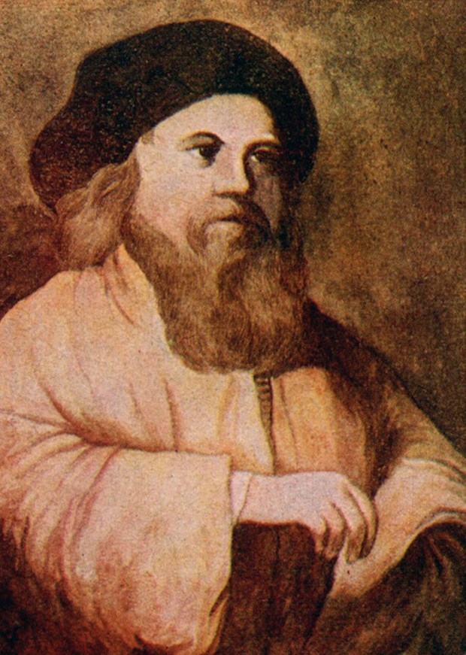
Painting of the Baal Shem Tov

When the Baal Shem Tov was about to pass away, he gathered together some of his close Talmidim and he told each one what their mission was going to be for the rest of their lives, in terms of spreading his teachings to others.
For one student he instructed him to teach his Divrei Torah to as many people as possible. To another student the Baal Shem Tov told him to focus on Chesed with other Jews, in his name, as much as possible, and so on.

Instructed to Devote His Life to
Telling Over Baal Shem Tov Stories
To one particular student, the Baal Shem Tov said, “Your job is to say stories about me for the rest of your life, whenever you have the opportunity.” This particular Talmid was the storyteller of the Baal Shem Tov, and this was also how he made his Parnasah, as people would hire him to tell stories of the Baal Shem Tov.
One time, this student got a letter in the mail from a wealthy, elderly man, who was celebrating his 90th birthday, and he was gathering his family together to mark the occasion. He wanted to invite this storyteller to come for the weekend and provide the entertainment to his family.

Invited to Take Part in a Small Party
The student accepted the job offer and went to spend Shabbos with this man’s family. He set out to travel early, and he arrived at the wealthy man’s house on Thursday evening. The whole family came out to greet him and invited him to partake in a small party where he could already start telling some entertaining stories.
The storyteller came into the house and got ready to tell a story about the Baal Shem Tov. Everyone gathered around him and waited for the first story of the weekend, and just as he was about to begin, for some reason, his mind went completely blank, and he couldn’t remember any stories! He couldn’t understand it. He had spent many years collecting hundreds of stories, and he knew them all by heart. This was his life! Why couldn’t he suddenly remember a single story?
It was a little embarrassing for him, but the family reassured him, and said that he was probably just a little tired from his traveling that day, and they suggested that he get some rest, and he would try again the next day. He went to sleep, and he woke up the next morning refreshed, and he was able to remember all of his stories, and he outlined in his mind which ones he was going to say.

Again, He Couldn’t Remember a Single Story
On Friday afternoon, everyone gathered together and asked him for a story, but inexplicably, his memory failed him again, and he couldn’t remember a single story. This continued over the entire Shabbos. Every opportunity he had to say a story, his mind went completely blank, and he couldn’t remember a thing. He was entirely embarrassed, and everyone was disappointed.
On Motza’ei Shabbos, he was ashamed to face the elderly gentleman who organized the whole weekend, but he had no choice. He went over to apologize and said, “I’m so sorry. I ruined your party, and I ruined your weekend. I was supposed to come and say stories. I can’t explain why this is happening to me. It has never happened to me before, but I can’t remember a single story about the Baal Shem Tov.”
The man replied, “Hashem controls the world. It’s just a little disappointing.” The storyteller said, “I’m not taking any money from you. I didn’t do what you hired me for.” He got in his wagon and started to leave. He traveled just a few minutes down the road, and he stopped the wagon, jumped out, and ran back to the elderly man.
The man said to him, “Is everything okay?”
The storyteller answered, “I remembered one story!” He said that he would like to say it over, but not for money. He said, “I ruined your party, this is for free. For some reason, this one story came to me, and to tell you the truth, it’s not even one of my best stories. I don’t think I’ve ever said it before, I don’t even know the full story, but at least I can remember part of the story.”

Found Themselves in a
City He Didn’t Recognize
The man sat back to listen. “I remember once when I was by the Baal Shem Tov, years ago, The Baal Shem Tov took me aside and said we were going on a trip together. We got into the wagon, and then the Baal Shem Tov whispered something in the horse’s ears, and they started to go on their own. After some time, we found ourselves in a city that I never recognized. It was not a Jewish town, and interestingly, the horse stopped in front of the town church, and this was during their Sunday morning services. It was actually a little dangerous for us to be there.
I saw what happened there with my own eyes,” the storyteller said. “The Baal Shem Tov went up to the church and knocked on the door. The secretary opened, saw this Rabbi, and asked what he wanted. The Baal Shem Tov was not about to go into the church, but he said, ‘I would like you to go tell the priest that I want to speak with him. Tell him Yisroel Baal Shem Tov wants to talk to him.’
The secretary explained that at the moment, he was in the middle of leading the services and he couldn’t get him just then, but the Baal Shem Tov instructed the secretary to get him anyway. The secretary went, interrupted whatever was going on, and whispered the message to the priest.

Talking to the Priest for a Few Hours
When the priest heard who was there, he turned pale, and ran outside to see the Baal Shem Tov. The Baal Shem Tov and the priest went into a side house to have a conversation. I was just sitting there, waiting for the Baal Shem Tov to come out from his private meeting. After a few hours, they left the house, and the Baal Shem Tov came back to the wagon. I saw the priest’s eyes were red from crying, and then we left and came back home.”
The storyteller said, “That’s the end of the story. I know it’s not very dramatic, but that’s all I can remember.”
The man sat through the story, and when it finished, he fainted! Everyone panicked, but they were soon able to revive him. The family asked him what had happened and why he fainted? He responded, “That priest in the story. That was me!”
Everyone was stunned. The storyteller asked him, “What did the Baal Shem Tov tell you in that house?” The man replied, “What the Baal Shem Tov told me changed my life. He brought me from where I was to where I am now, and that’s between me and Hashem. I’m not going to tell you. I will tell you one thing, though. After I decided to do Teshuvah, I asked the Baal Shem Tov, ‘Rebbe, how can I know that my Teshuvah has been accepted in Shamayim? Can you give me some type of sign?’
The Baal Shem Tov told me that if at one point in my life one of his students comes and tells me my story, that will be the sign that my Teshuvah has been accepted. Ever since then, I’ve been hiring all sorts of storytellers as much as I possibly can, just to hear stories of the Baal Shem Tov, hoping that I would hear my own story. That was why I said it was disappointing when you couldn’t remember any stories. But finally, after so many years, this is the story that I’ve been waiting my whole life for, to hear my own story!”

Reprinted from the Parshas Vayigash 5783 email of Rabbi Yehuda Winzelberg’s Torah U’Tefilah.
Hit a Home Run
For Your People!
By Rebbetzin Esther Jungreis

Some years ago, President George W. Bush appointed me to the board of the United States Holocaust Memorial Museum, which brought me quite frequently to Washington. On one of these occasions, following a board meeting, I was walking on the street when a young rabbi with a large group of students spotted me.
He came running. “Rebbetzin!” he exclaimed, “I’m so happy I’m meeting you! I have here my talmidim,” he went on, pointing to the young boys. “Could you offer them some words of chizuk and inspiration?”

Not Quite the Perfect Venue
In the street, amid the noise of passing traffic, with my young audience distracted by the sights — that was not exactly the venue in which I would choose to speak. But I do believe everything is bashert.
So, if I encountered these young boys, and their rabbi asked me to address them, how could I say no?
“Are you all into sports?” I asked.
My question was greeted with an enthusiastic yes. “Then let me tell you a sports story,” I said, “and put it away into your hearts and your minds. And one day, please G-d, you will tell it to your own children and grandchildren.
“Once there was a highly successful sports team. Tickets to their games were very much coveted, and when they played, the stadium was sold out. And then, there was some internal fighting among the team. The players were angry at each other. Some quit and joined other teams, other players failed to train, and still others became indifferent. The only ones who were left were the fans.

Can a Team Survive with Only its Fans?
“Now, let me ask you,” I challenged the boys, “do you think a team can survive with only its fans?”
“You must be kidding!” they responded. “Of course not! It’s a no-brainer!”
“You’re right,” I said, “it is a no-brainer. But unfortunately, that is what happened to us, the Jewish People. We have many ‘fans.’ Bar mitzvah parties galore. But does having a party mean that the bar mitzvah boy fulfills the challenge of being a bar mitzvah — which means ‘son of mitzvos, commandments’? Does he put on tefillin every morning? Does he go to minyan? Does he study Torah? Is that guy a player or a fan?
“I’m a Holocaust survivor,” I went on. “When I was your age, I was in the ghettos, the concentration camps, the displaced persons camps. My zeides, my bubbes, my aunts, uncles, and cousins — all holy people, great players for Hashem’s team — can no longer play.
“So, listen, boys,” I said. “You have an awesome responsibility. You must pray for them, for they can no longer pray. You must study Torah for them, for they can no longer study. You must give tzedakah for them, for they can no longer give tzedakah. You must do mitzvos for them, for they can no longer do mitzvos.
“So, guys, listen to me,” I said. “Go into the field and hit a home run for your people. Build up your team and make it better than ever. And if you do, the stadium will be filled and everyone will be cheering. You can restore the faith of our people. Make our people win. Let us build a team of Torah, and spread the holy rays of blessing, truth, kindness, integrity, wisdom, and righteousness, which are all contained in our Torah. We need only to bring them forth.”

Reprinted from At the Artscroll Shabbos Table. Excerpted from the new book – “Be a Blessing - A Guide to Living One’s Mission to the Fullest” by Rebbetzin Esther Jungreis.

The Night the Chazon Ish Went to Sleep Early
By Rabbi Mordechai Levin

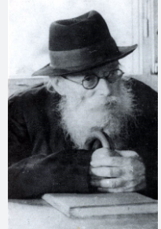

A Rosh Yeshiva once came to the Chazon Ish, ZT”L to request permission to expel a student who wasn’t following the rules of the yeshiva, and was a bad influence on others. Reluctantly, the Chazon Ish allowed it. However, he told the Rosh Yeshiva to ask the student if he would agree to learn with the Chazon Ish, as he was “looking” for a study partner. Thus began a seven-year relationship between the young man and the great Chazon Ish, in fact for a number of those years he actually lived in the Chazon Ish’s home.
He carefully observed the Chazon Ish and wrote down all that he witnessed. The Chazon Ish was a tremendous masmid, one who studied Torah with all his physical strength. His nightly routine was that he famously learned until he had no more strength, and then collapsed onto his bed to rest. He leaned his head against the wall and left the lamp burning. As soon as he felt his strength return, he would resume his learning.
One day, a bochur from the Mir Yeshiva came to stay overnight in the home of the Chazon Ish. As he prepared to go to sleep, a strange thing occurred. The Chazon Ish also began preparing for bed and changed into pajamas. When the bochur got into bed, the Chazon Ish asked his student to put out the lamp. The room was dark and all three inhabitants went to sleep.
The next morning, the student asked the Chazon Ish about his unusual behavior the night before. He had never before seen the Chazon Ish change clothing and prepare for sleep, nor had he ever seen him lay in the dark.
The Chazon Ish explained that he was concerned that the Mirrer bochur wouldn’t sleep properly if the Chazon Ish was learning and with the lamp on in the room; therefore, he went to bed and asked that the lamp be extinguished.
Although the Chazon Ish lived in a spiritual world, he concerned himself with the welfare of others. He gave his precious time to facilitate the well-being of his fellow Jew. (Reprinted from the Parshas Vayigash 5783 email of Torah Sweets)

Rebbe and Talmid (Student)

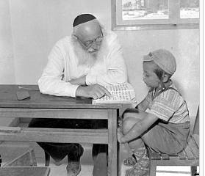

A cheder (classroom) in Bnei Brak, Israel, circa 1965 (courtesy of the National Library of Israel)

